**Wine Analysis – Pinot Noir**

**Dashboard**

Wine quality is a complex concept that can be hard to define. Wine is a product destined to not only be consumed and appreciated but also marketed, and its quality, cost and berry colour are important characteristics that describe a wine’s sensory profile and, ultimately, add value to the finished product. We collect data from 8 different regions in New Zealand: Clayvin Single Vineyard, Pencarrow, Bendigo, McCrone, Clos Henri, Aroha, Escarpment, Block 3, Cornish Point, Clayvin, Greystone, Roaring Meg, Moutere, Pencarrow, Main Divide, Stoneleigh, Bendigo, Old Coach Rd.

There are four graphs in the main screen: “Wind Qualities”, “Cost”, “Berry Colors” and “Quality/Cost”.

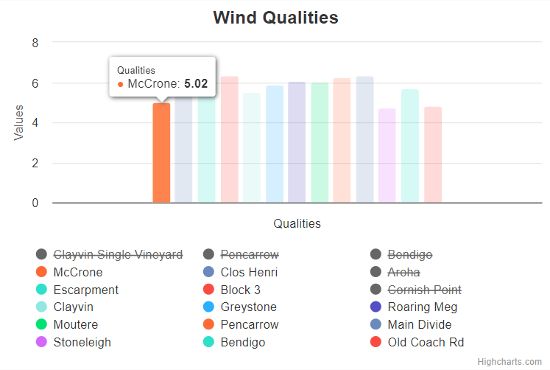 The web application allows users to adjust the bar garph by omiting some regions

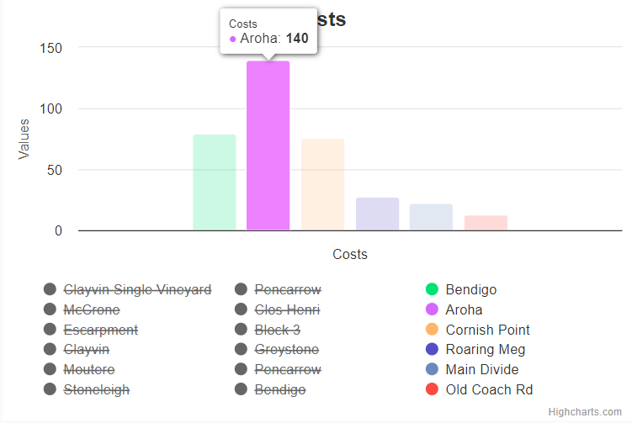

The information of each region is displayed when use mouse over.

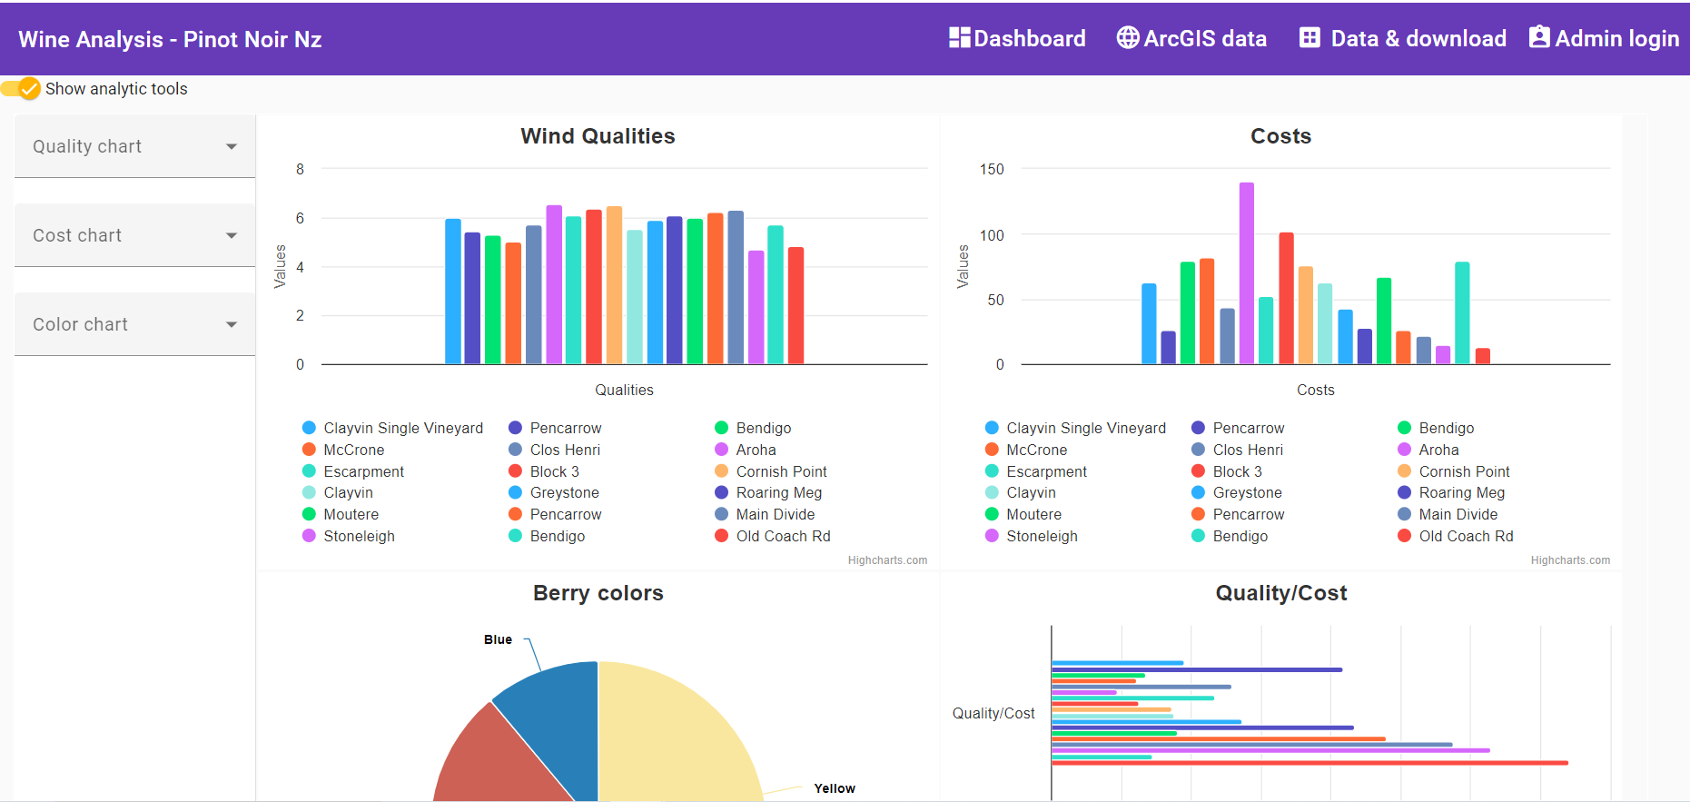

Users can select the slide toggle to show the filtering options. There are three filtering options for quality chart, cost chart and colour chart, as follows.

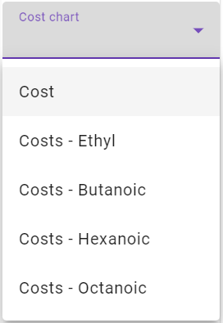

**ArcGIS data**

Using the agriculture geographic information system can be a tool for better decision making for quality (or quantity) grape growing and wine making. The web application illustrates the agriculture geographic information (2013, 2016) of the 18 regions around New Zealand.

The web application can show the agriculture geographic information of the region with high production or low production, following the selection of users.

**Data and Download**

The web application shows the metadata of the 18 regions in New Zealand, which contains the producer data, vineyard data and vintage data etc. To see this information, user can click on the “Metadata” tab.

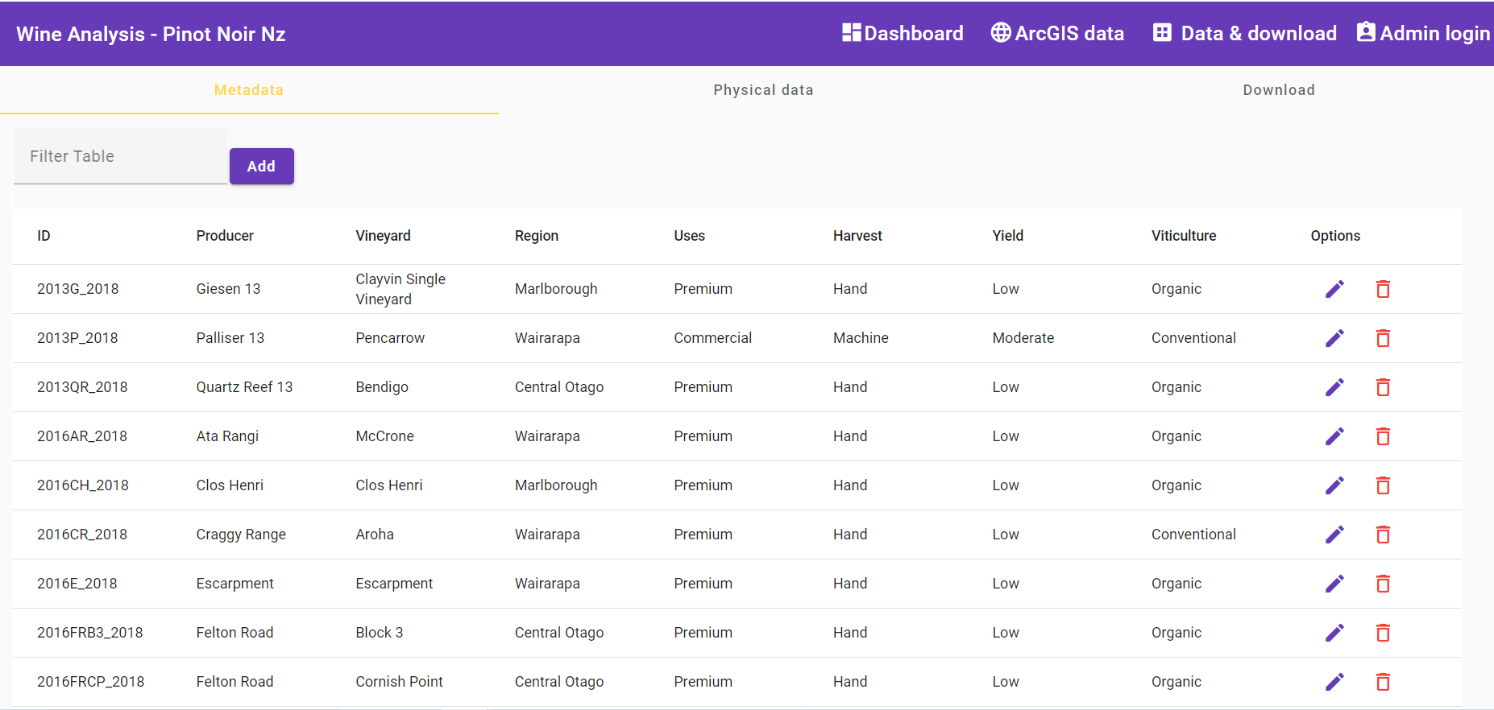

Also, the physical data, which is important information for the wine quality analysis, is shown in the web application. User can click on the “Physical data” tab to see this information.

Remark: these two data can be edited by the Administrator user only.

In case the non-administrative users click on the options to arrange the data, the web application will alarm the message “Only admins and superusers are allowed”.

Furthermore, the relevant data to wind quality analysis are available in the web application for downloading. User can click on the “Download” tab.

**Admin login**

Administrator users can sign in for arranging the metadata and physical data, by inputting email addresses and password in the “Admin login” screen.

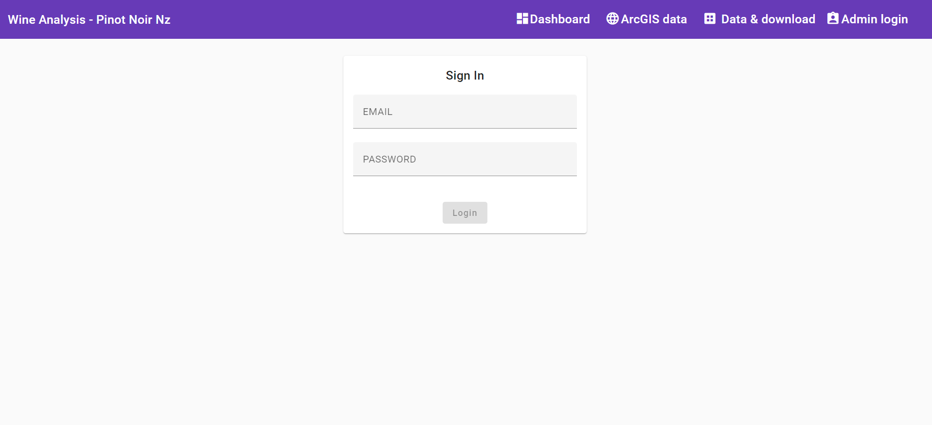

After the administrator user signing in, the web application will show “Signed in” status.

The administrator users are allowed to edit-delete-update the data.

